**Wiring the Lights**

4x lighting rods with neopixel strips

Bluetooth HC-05

Arduino Uno

7.2A(or higher), 5V DC power source

**Wiring Diagram:**

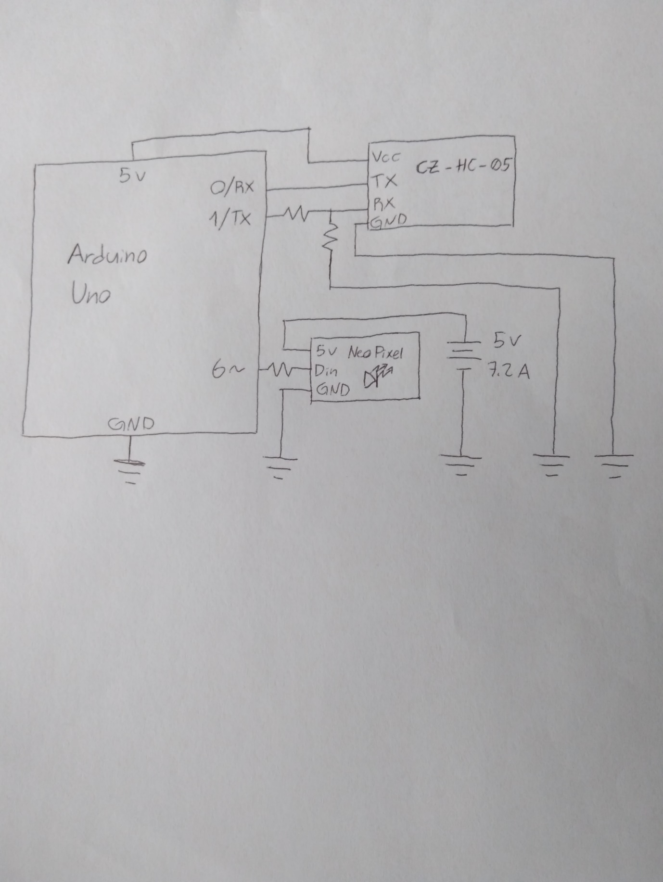

2KΩ

1KΩ

470Ω

Attaching the Bluetooth HC-05

The prototype board you have has been set up to plug into an Arduino Uno like a shield, as shown below

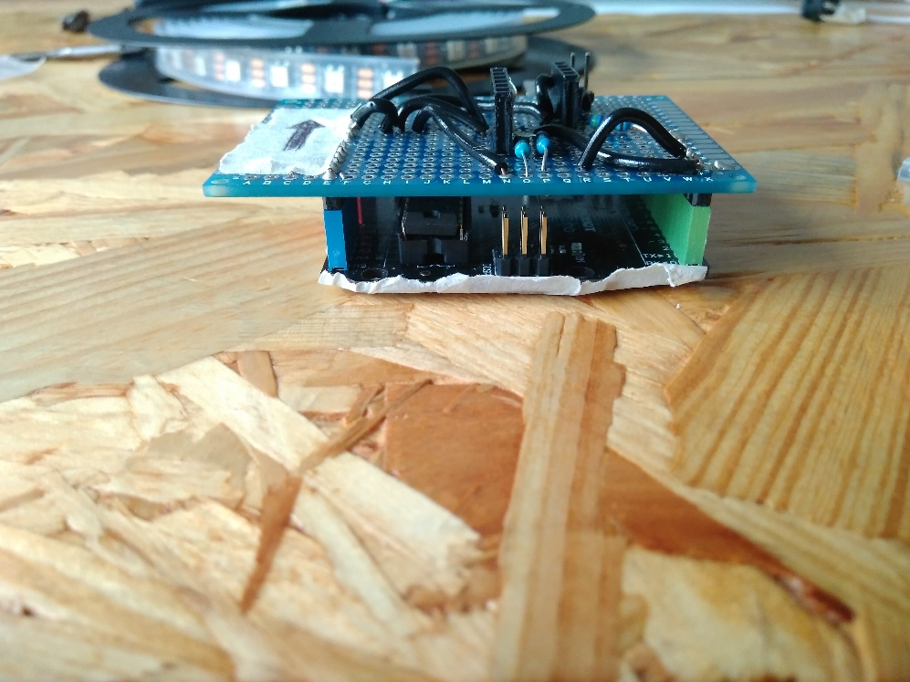

After plugging it in, attach the Bluetooth HC-05 chip according to the labels on the shield.

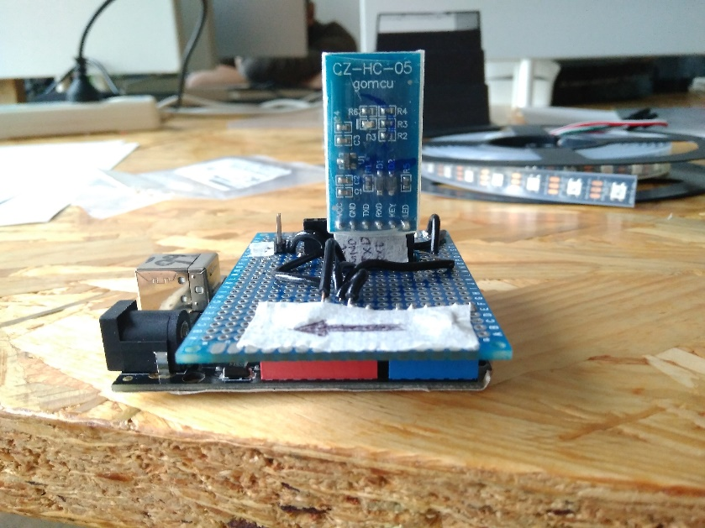

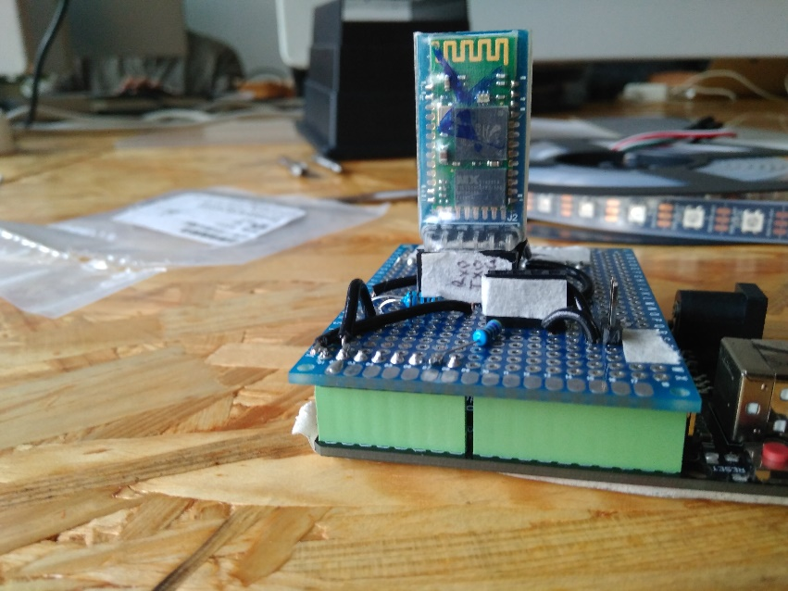

Connect the DC female connector as shown below following the labelling on the shield and wires.

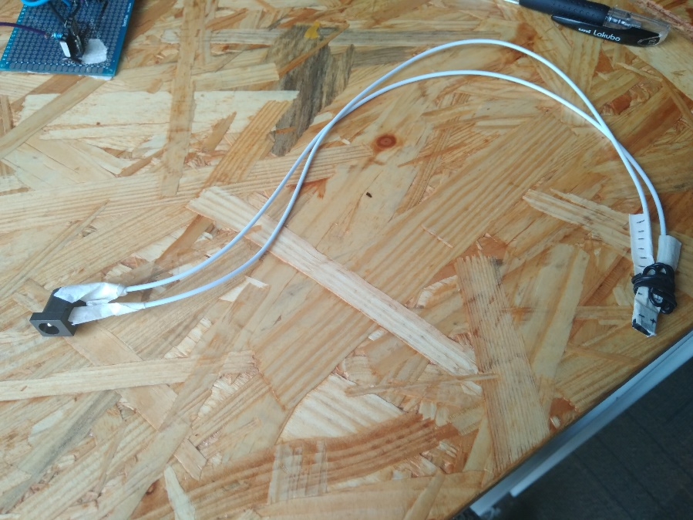

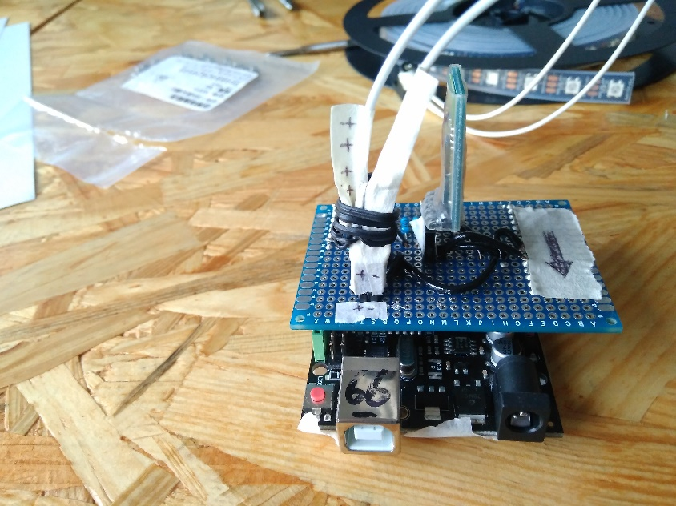

Connect the Left-side neopixel light strip, following the labels on the wires and shield (ideally you should do this once the lights have all been mounted.

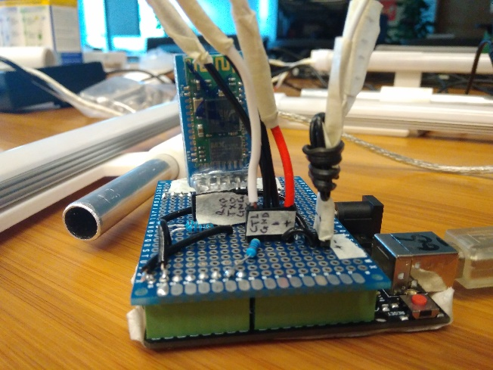

You can now connect a DC power source to the connector, and connect the Arduino to either a DC or USB power source.

Upload the code from the GitHub for either typed(recommended) or button controls.

When mounting neopixels to the frame, keep in mind the directionality of the strips. These are labelled at the end of each wire on the lights. To fit with the code, the lights should be arranged going clockwise, starting at the bottom left corner. The wire on the left side light should be longer, to connect to the shield.

Once the neopixels have been mounted onto the frame, connect the lights to eachother with female-to-female header cables, matching the wire colors.

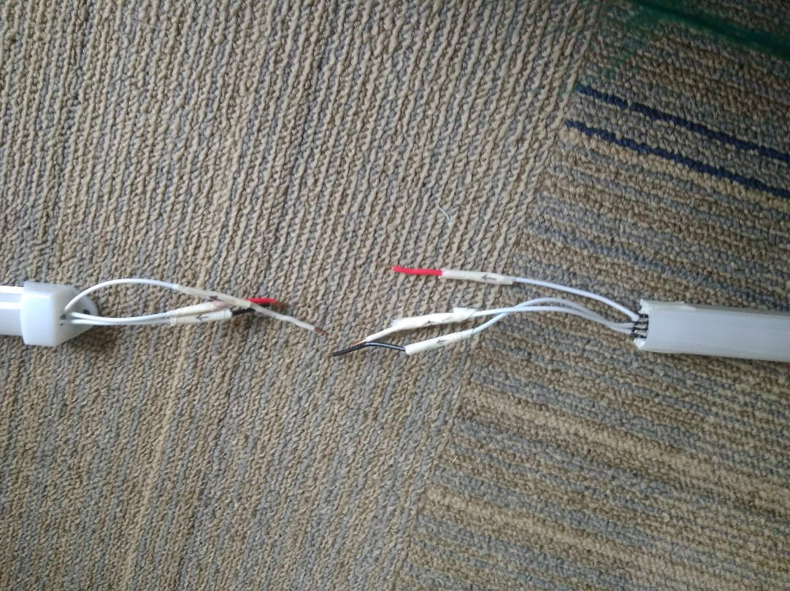

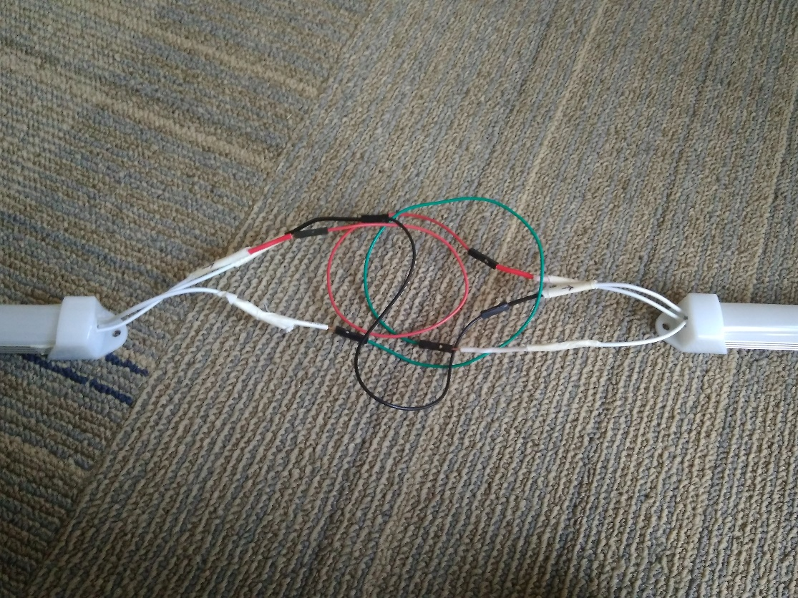

The bottom light strip will not have wires on one of it’s ends, as this does not need connections.

Controlling via Bluetooth

Download one of the apps on the App store or Play store for the HC-05, as shown below.

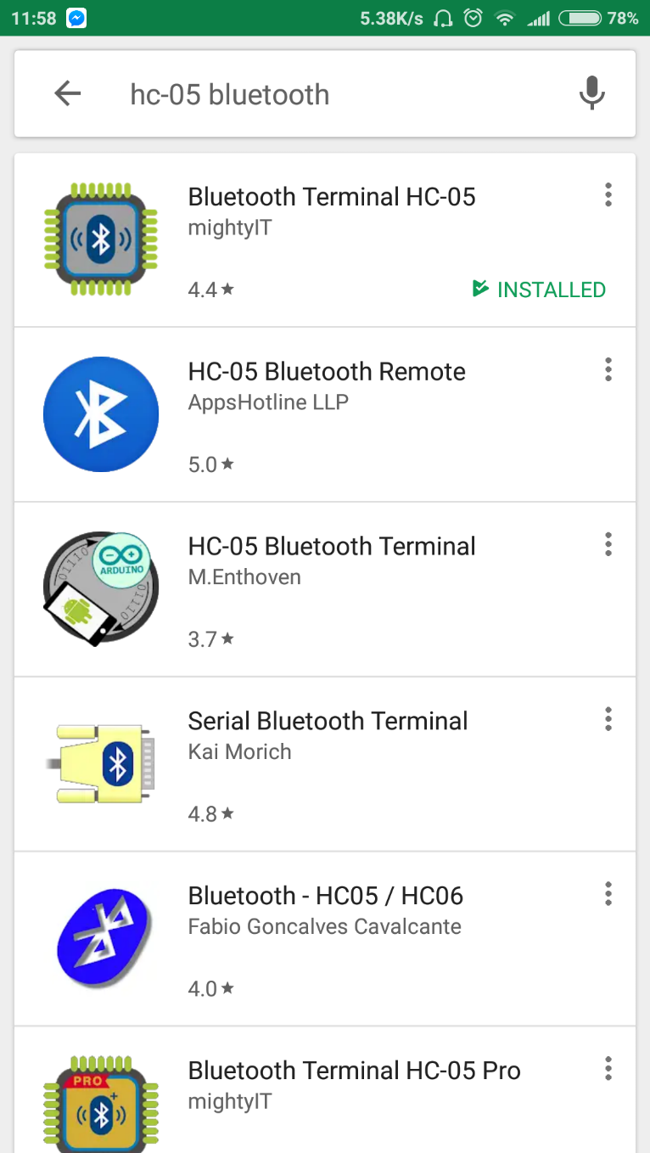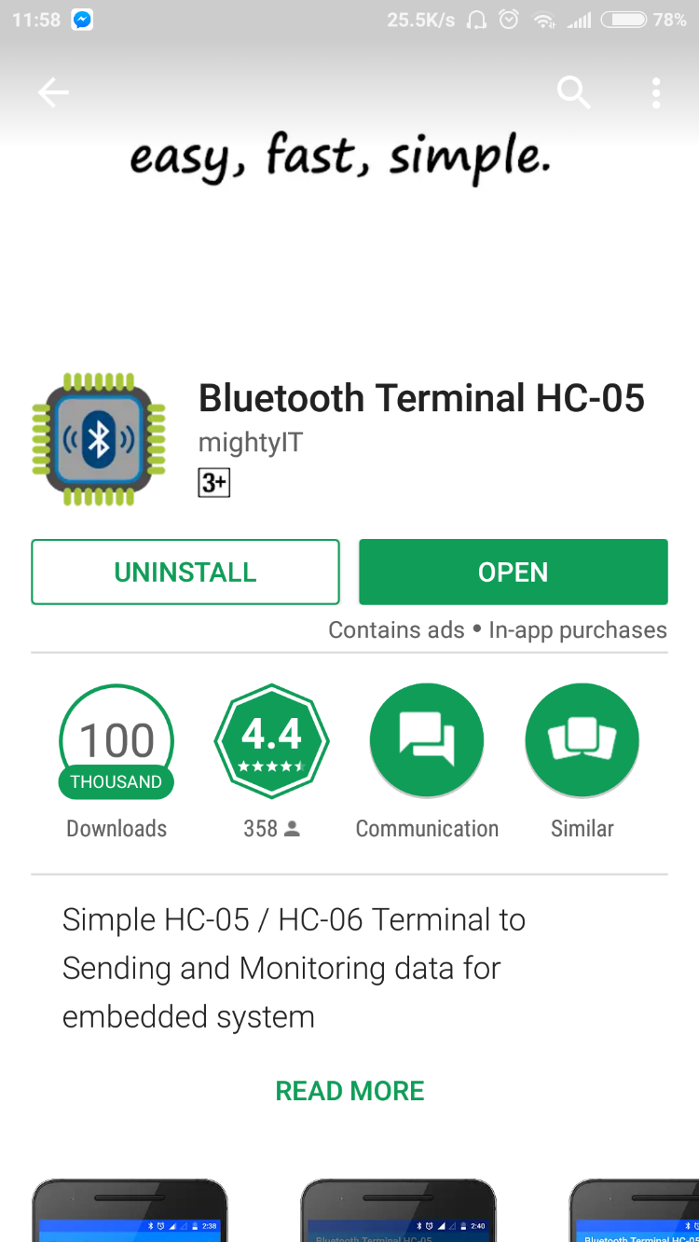O

Turn on Bluetooth and while your Arduino is wired and plugged in, connect your phone to the HC-05. Open the App and select the HC-05 from the list. You should be brought to a screen that looks like this:

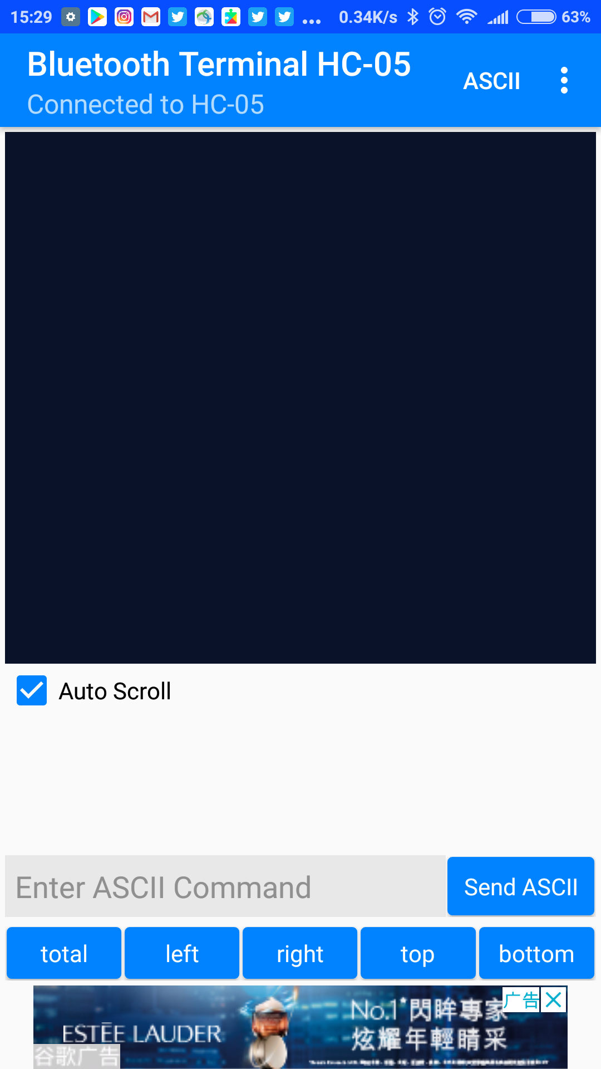

You will need to set up the buttons on the bottom of the screen to send the correct command.You need to assign the ASCII commands “left”, “right”, “top”, “bottom”, and “all”. Do this by long pressing each button and filling it in like below:

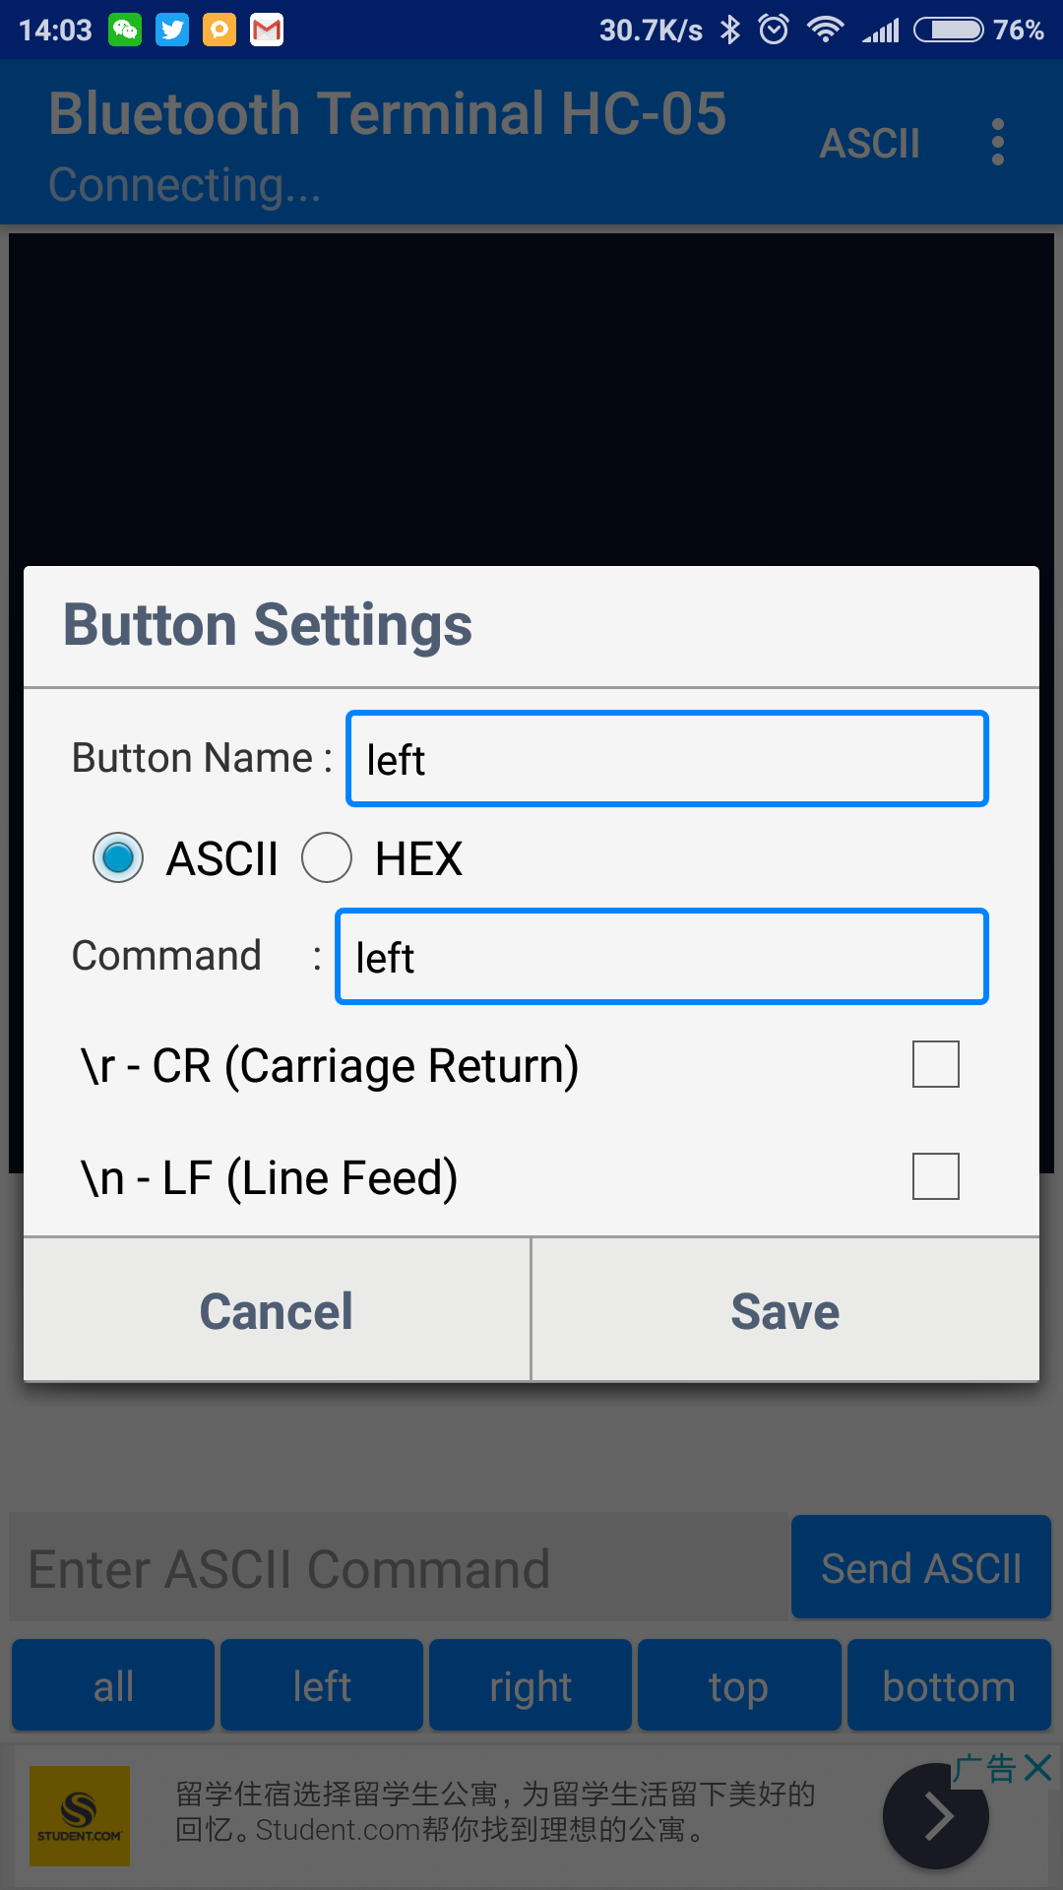

You can now press a button to select a side. Text should appear indicating the side has been selected.

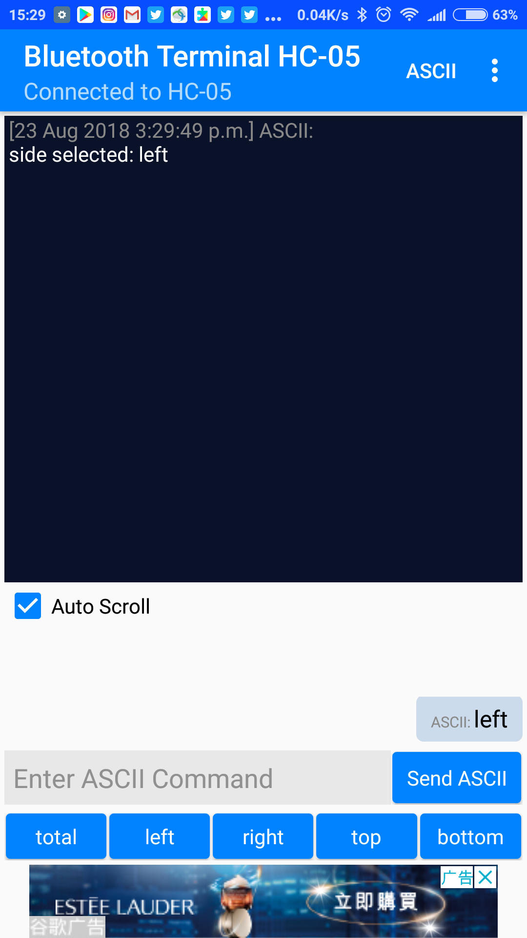

Then tap on the “Enter ASCII Command” bar and enter a number between 0-255 to assign a brightness for that side. Then hit “Send ASCII”. You should get text indicating that your brightness has been selected. This should be reflected in the lighting rig.

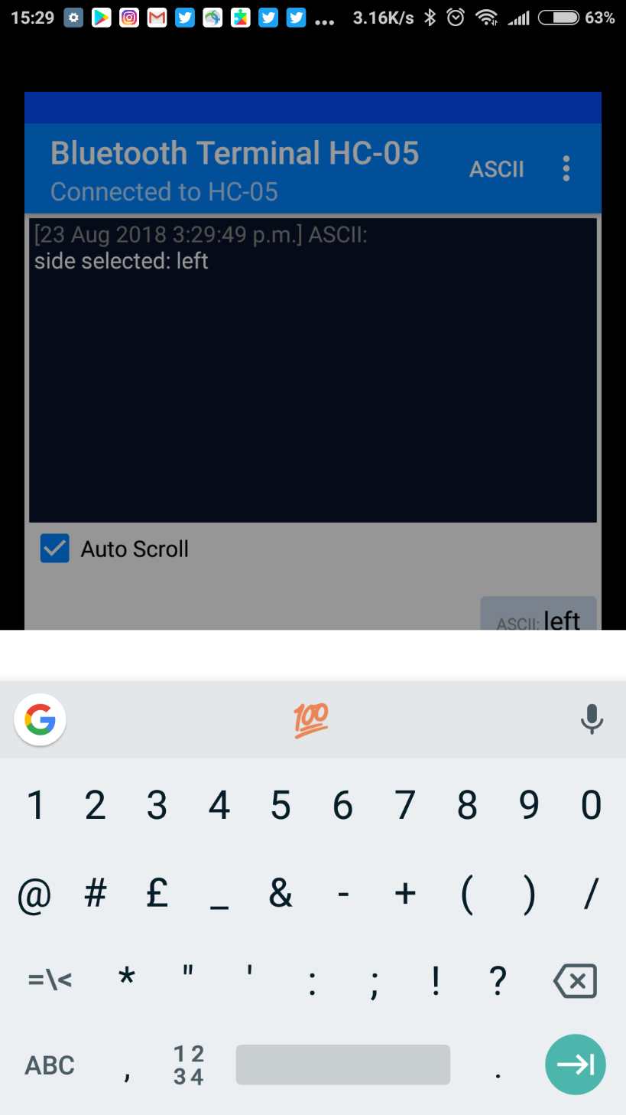

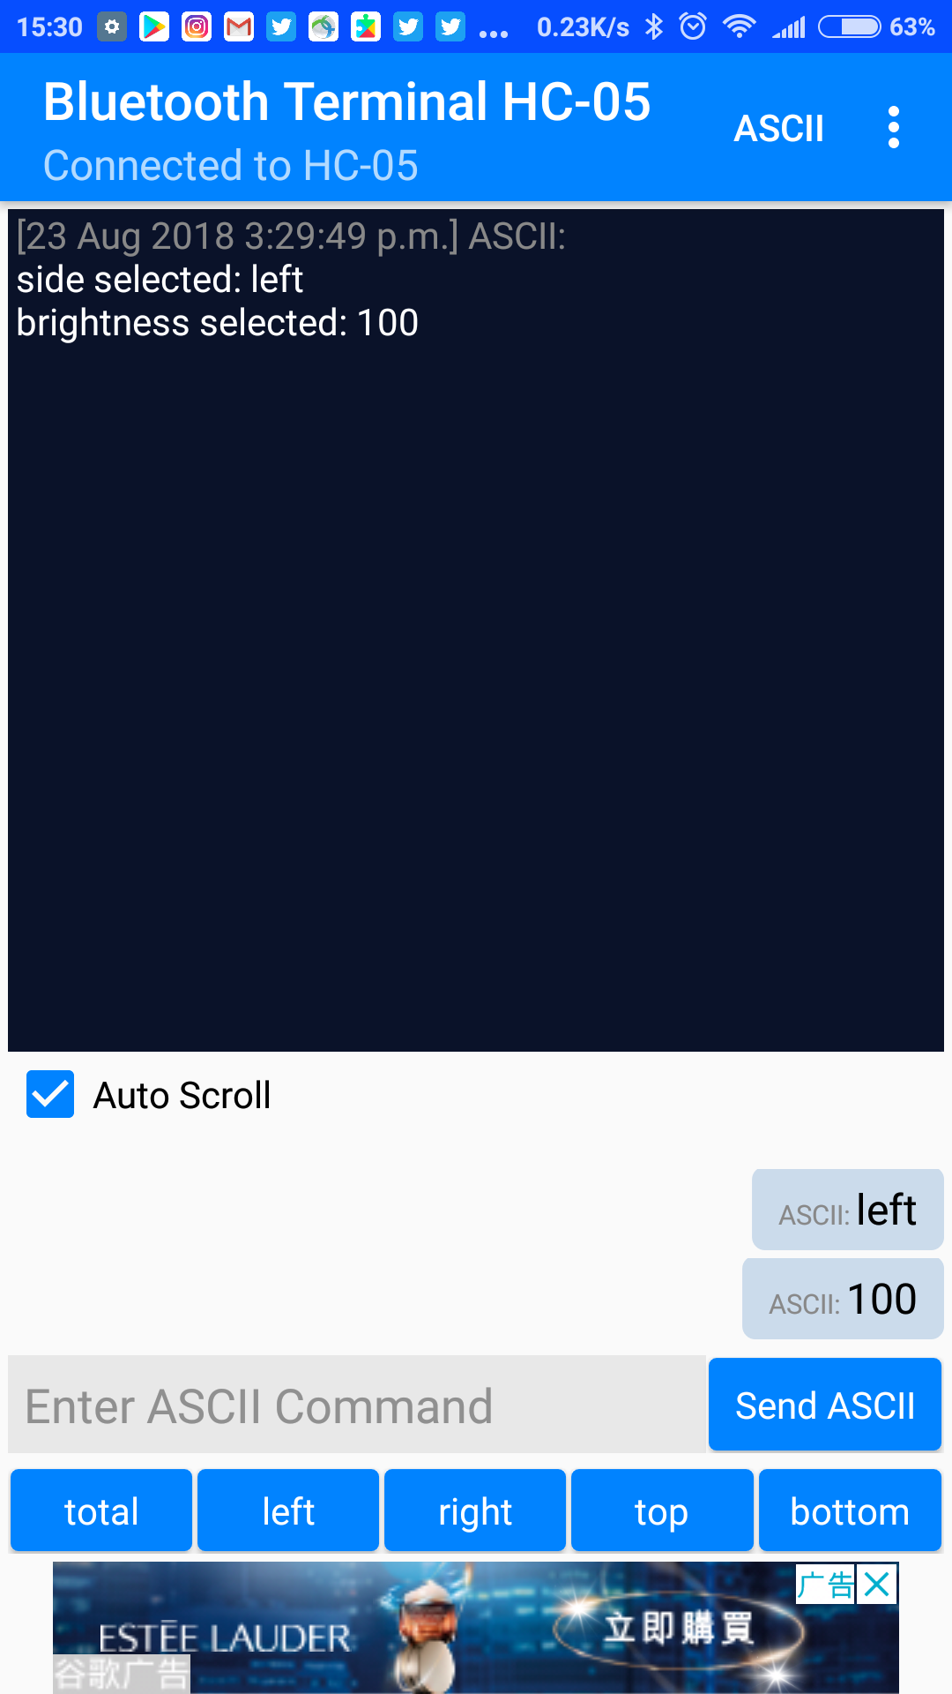

You also have the option to select sides through text entry, as shown below:

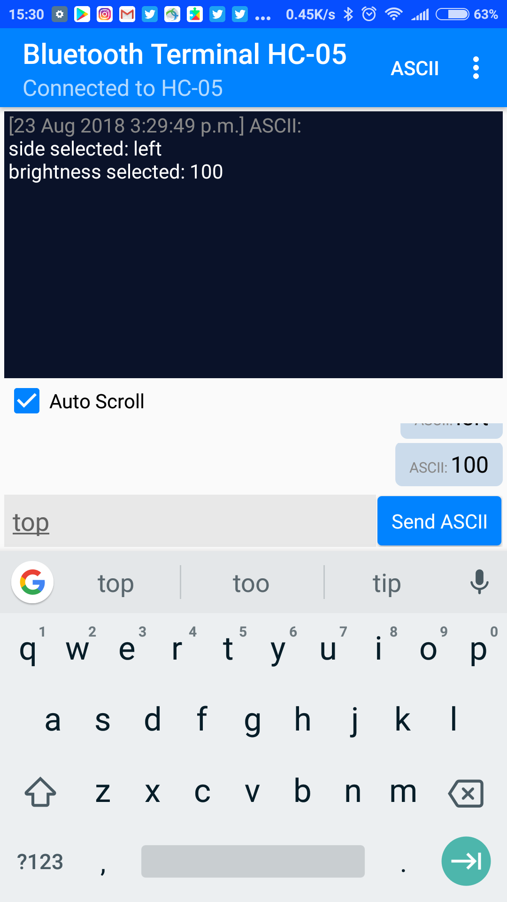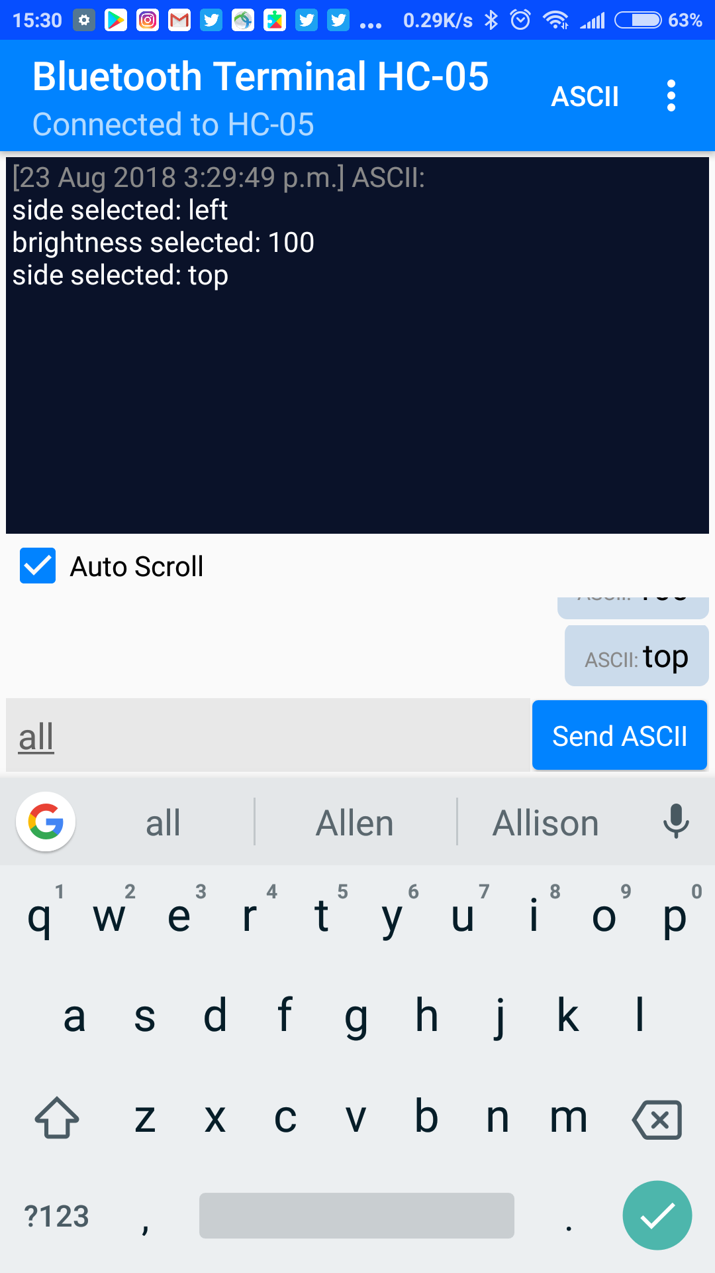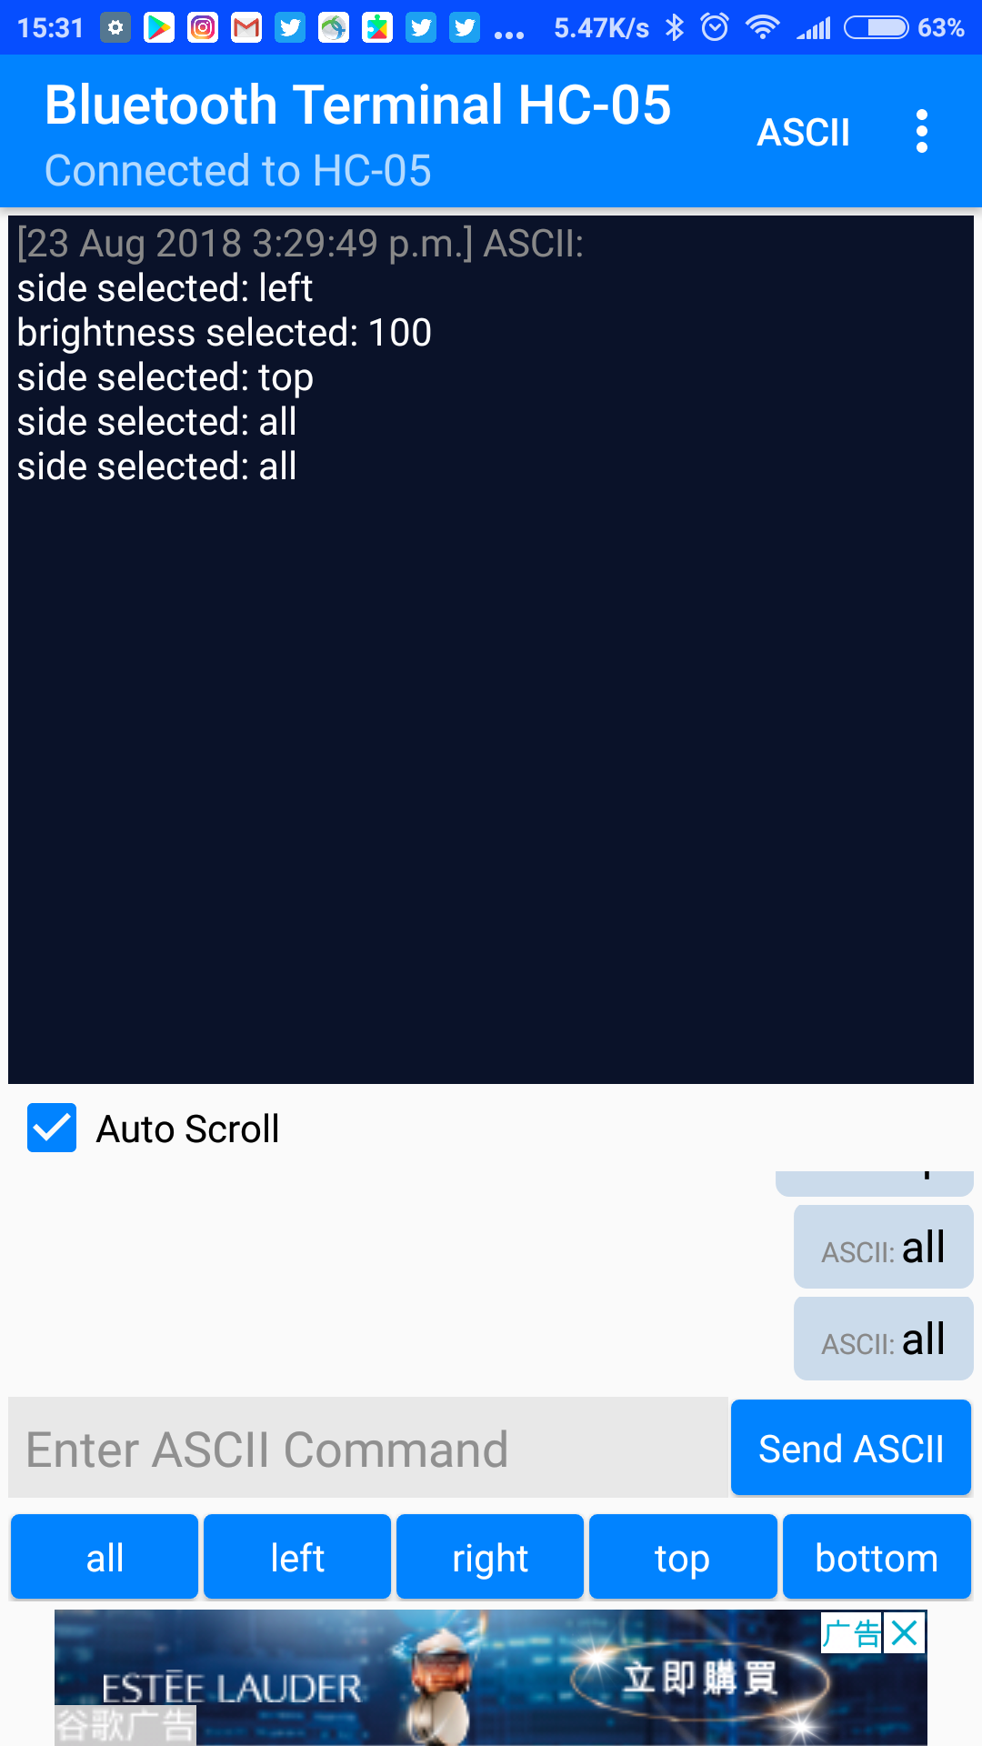

The Button code functions similarly, except that the pressing the buttons will increase each side’s lights by 50.

The Arduino code has been made for a set of lights containing 120 neopixels, with 24 on the vertical sides and 36 on the horizontal sides. This can be modified in the code.